WORKING TOWARDS THE SUSTAINABLE TRANSFORMATION OF EDUCATION SYSTEMS LINKED WITH TECH-TRAD METHODS

A Dissertation submitted in partial fulfilment of the requirements
the degree of
Bachelors of Science (Hons.)
in
ENVIRONMENTAL SCIENCE
Submitted by
RAJAK DEEPU KUMAR
PRN – 2020033800061234
Under the Supervision of
Dr. SWAYAM SIDDHA

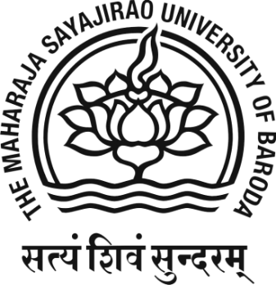

Department of Environmental Science
Faculty of Science
THE MAHARAJA SAYAJIRAO UNIVERSITY OF BARODA
2023

